2023 – Board Meeting @ Denny Field
Attendees – Nick Druga, Julie McDermott, Ben Sheets, Kim Rios, Kate Koch, Joshua Dadeboe, Carly Kohler, Holly Levin, Jess Jackson, JG Wiles
Not in attendance – Amy Proie, Courtney Bianchi
Roadmap 2023
Month | Season | Development | Events | Communications | Board Member Activities
January | In House Futsal* | Winter Skills* (6 sessions) |  | Spring Registration | Township Field Permits for Year  Finalize Spring Coaches
February | In House Futsal* - Ends 3/3 | Winter Skills* | All Coaches Meeting 3/7 |  | Spring Registration Closes 2/12  Spring Teams Declared 3/1
March |  |  | Coach’s meeting – 3/7 – Marzolf  Dick's SG Day 3/18-3/21 | Spring Permits begin – Anderson/ Scott | Field Set Up 4/1 – Fall field clean up made Spring EASY!
April | Spring |  | Spring Flower Fundraiser – email out: Due on April 23th | Remind coaches in Recreational– flowers due on April 23th
May | Spring | Spring Fling – U8 Festival @ Denny  5/27 - CANX | Spring Flower Pick-up – 5/13 | Fall Registration | Fall Registration Opens – 5/1 – 6/30
June | Spring | Summer Skills (6 Sessions)  Summer Complete Moves (6 sessions) | Last Week June  Pick Up Nights  PA West Open | Fall Registration | Finalize Fall Coaches  Fall Open Registration closes – 6/30
July |  | Summer Skills  Summer Complete Moves  UGKA training? | Pick Up Nights  Parent & Kid Pick Up Night  New Coaches Meeting  Coaches Meeting |  | Fall late Registration Closes – 7/12  Fall Teams Declared
August | Fall | Summer Skills  Summer Complete Moves  Pre-Season Sessions  UGKA training? | Pick Up Nights  Parent & Kids  Dick's SG Day  Sponsor Fundraiser  Plum Kick Off Tournament |  | Fall Clean Up day – Date TBD
September | Fall | Fall Complete Moves (6 sessions) | Mum Fundraiser  Homecoming Parade – 9/30  Fall SSC Photos
October | Fall | Fall Complete Moves | Sponsor Fundraiser  U10 - Fox Chapel Moonlight Madness | Futsal  Winter Skills | In House Futsal Registration Opens*  Winter Skills Registration Opens*
November | Fall | Fall Complete Moves | Annual General Meeting – Date TBD | Futsal  Winter Skills | Field Close Down
December |  |  | Sponsor Fundraiser | Spring Registration – Starts 12/1 | Spring Registration Opens  In House Futsal Registration Closes*  Winter Skills Registration Closes*

July
Sunday, July 23, 2023
- Nick – President report
  - Fridge – delivered broken, new fridge coming tomorrow!
    - Joshua will be there to receive it
    - Concession stand in general
    - Volunteer – 80% filled slots per week
      - Sundays – open/closers are getting email
      - Slots being locked on Fridays to lessen issues
      - Now it’s working
      - 40 people are done
      - Need to be 13 or older
    - Flowers
      - Exposure for Wendy
      - No drama for trucks
      - Learning Pros and cons
      - Vouchers
      - Delivery
  - Varsity Boys Game – 9/28
    - Email to the club
    - JV game at 6:00PM
    - Varsity Game at 7:30 PM – be there by 7:00PM
  - Varsity Girls Game – will have a game
  - RMU – Women’s game – not great turnout, but did have a few families
  - Homecoming
    - PUSH to get as many kids as we can
    - Make sure to communicate
    - Enormous candy stash once we hit the library/viewing stand
    - Coordinating with Matt Kohler
    - Asked to throw the candy into the crowd
  - Saturday Performance
  - AGM – Wednesday November 8th
    - 6:00 – 10:00 PM (but we will not be taking until 10)
  - Saturday – InHouse - Ben
    - Signage in the concession stand
    - Seem to be better as we go on
    - Guidance on the maps for the fields
    - TOPS –
      - approached by Lilly (North Hills), Ashley (Shaler) have recommendations and we may get thank yous
      - Looking for a director of tops for the new alignment of the board positions
    - Lil Kickers – good commissioners this year for all ages

  - ICL/Travel – Julie
    - Looking to get the new schedules
    - Last week, there was a parent who was asked to leave the game by a coach
    - Coach let us know, the parent did reach out to us
    - Parent did reference the code of conduct, one time
    - They had a game tonight – all’s quiet
    - The parent did ask to not have the center ref – Craig McCallen
    - Hopefully resolved in the next 2 weeks with the schedule updates – seen considerable amount of blowouts, in our favor but realignment
- Kim – Registrar
  - Multiple Gym spaces – for sure what days by next week
  - Mike Bianchi (U8 and below) - reached out to do titan training in partnership with the school – footskills for little kids
  - Inhouse futsal
  - Spring opening December 1 until January 30^{th,} February 12th late deadline
  - Clay’s older team played in last winter – Marx court time running a futsal league in either elizabeth or PISA, no Futsal/assassins (over October 1st)
    - Outside the club, responsibility to take your own team
    - Try to get the kids involved
    - Monthly tournaments –
  - Uniforms – want to start to not order uniforms
    - Same numbers,
    - Checks for volunteers would be more difficult
    - Nightmare in Joshua’s hand
    - Think through it – need to figure this out can’t be a barrier to entry
    - If they refuse, not welcome back
    - Things to think about – add an option to buy an additional jersey
- Joshua – Treasurer
  - Financial Health is good
- Kate – Secretary
  - Emails good
- Spring Fling
  - Parent volunteers, will send an email to U8s
  - Donation, etc.
  - Date – first weekend? Last weekend?
- Board Reports
  - Jess – Concessions
  - Holly – Communication/Volunteer
  - JG – Clearances
  - Steve – U10
  - Carly – Spring Fling 2024
- Bylaws at the AGM – Sent again to the group
  - If voted in, it would be accepted
    - Bylaws would dictate up to 15 directors would be
    - Number of directors would be determined by the directors
    - Aligning with the 501c3
    - Directors after elected – vote President, Vice President, Secretary, Registrar and Treasurer
    - We used to have folks do very specific roles, and then when not done, the e-board did them.
    - Sometimes when people excelled, sometimes they didn’t do anything at all
    - After seeing what works/doesn’t work – reviewed with the e-board
      - President – reports back to PA West – Advocate with Shaler soccer club
      - Day to Day – VP, Secretary, Treasurer, Registrar will then have the directors
      - See Flow Chart

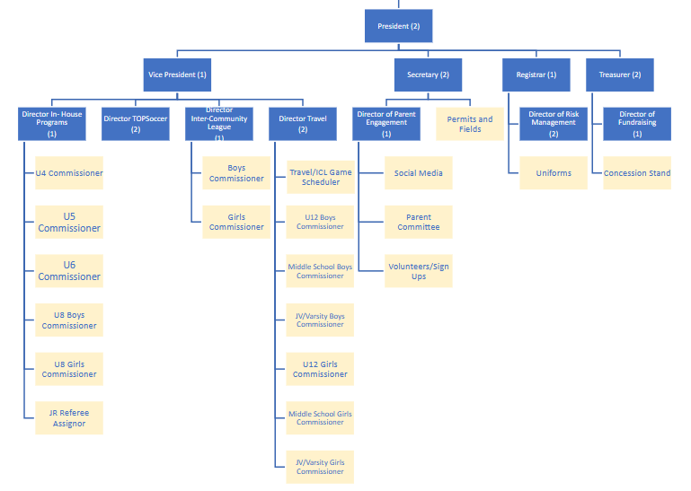

- For InHouse
  - Reality vs. On Paper
  - Commissioner coordinator
  - U4-U6 are typically chaos – hard to manage
  - Coaches
  - The VP need to look across the whole
  - Commissioners and Coaches split (a LOT of new coaches with questions)
- We have this meeting and next meeting to discuss and continue to refine
- Term of the roles are listed in the squares above with the term limits on the years in parentheses
- Nominating committees -
  - New Business: None
- Motion to adjourn: Josh/Ben secondAdjourned

